**Project plan**

1. **Introduction**
2. **Requirements**
3. **Goals & Objectives**
4. **Schedule**
5. **Groups**
6. **System design**
7. **Goals & Objectives**
8. **Involving device/Technique**
9. **Reference**
10. **Introduction**
    1. **Background**

Vital signs are used in medicine to determine the severity and urgency of a patient’s physical condition. The four major components are respiration, body temperature, pulse, and blood temperature. Vital signs are of great significance to the predication of serious disease such as cardiovascular and diabetes mellitus. To curb the growing incidence of diseases, technology to monitor vital signs is becoming increasingly significant. According to the statistics from WTO, cardiovascular disease (CVDs) is the most fatal of death worldwide, the rate of death is always at the top among all disease. **[1]**. Diabetes mellitus (DM) is considered as a global epidemic, which makes a great influence on global population. Due to an approximately estimation, 6%-8% of world’s population is suffer from DM. Compared to the number of 336 million affected people in 2011, it predicts that in 2030, the increase will be 50.8% and nearly 552 million people will involve in DM **[2]**.

Therefore, it is vital important for researchers to develop new technology to monitor the signs. Numerous investigations have been devoted to vital signs. It is proved that by the combination of machine learning with monitored data, it can improve the prediction accuracy of cardiovascular.**[3]** However, it is not adequate to meet the requirements of every user. For the pregnancy, mood symptoms are especially important. Prenatal depression can cause serious complications which are harmful for both pregnancies and fetus.**[4]**

There are some companies have developed mobile system that for monitoring vital signs. However, the function of these systems is too limited. The Xiaomi system could only monitor hear rate and the user cannot view tracks by period. The Huawei system therefore has an unstable data reception and can only monitor few of physical parameters. A common flaw in existing system is the inability in integrating data. This property is also essential for complete detection system.

* 1. **Motivation**

There are already many different systems on the market, such as Apple, Xiaomi, and Huawei. In general, these systems all have basic functions such as measuring heart rate or temperature. However, there is no integrated system designed for the pregnancy women. For example, the Xiaomi system is inadequate in monitoring heart rate, users cannot view tracks by period. For Huawei system, its data reception is unstable which may lead to the imprecision of receiving data. This cluster of data monitoring is not user friendly. An­­ ideal system should not only has the basic functions, but also has extra functions designed for the pregnancy. The system could compare the user’s data with the average data, producing line charts for user to check. Moreover, the system could integrate all the statistics received from the devices and automatically output a report with some suggestions for user.

* 1. **Aims & Objectives**

Our main purpose aims to build a system that integrate all data and generate a report for the user. Considering the open source information currently available on the device, an Android application will be developed. The system can monitor the users’ health condition (eg. heart rate, blood pressure…) and output a report for the user. In addition, the algorithm applied algorithm developed by the PhDs and research team.

1. **Requirements**
2. **Goals & Objectives**

The final goal of the project is to develop a monitoring system to receive data from devices.

* 1. **Requirements Specification**

Initially, the discussion was done in group to speculate users’ requirements. By attending the workshop with other group of the same project, information from testee was collected and parameters of devices are received. Finally, meeting with supervisor helps to modify requirement and affirm the goals of the subsequent project.

* 1. **Interim report**

Done by the half-stage of the project. The report should include 3 main parts. Firstly, the **current stage of project** should be mentioned, including **updated and expanded description of problem**, **background information** about the research, **requirement specification** for project, **initial design** (about system, prototype, and implementation) and **key implementation decisions**. The second part is about future, which includes discussion about problem encountered and time plan for the project. The last part is details, covering project name, group members and supervisor and so on.

* 1. **System Design**

The system is designed into 5 modules, which can implement respective functions. The details about each module are shown below.

* 1. **Prototype**

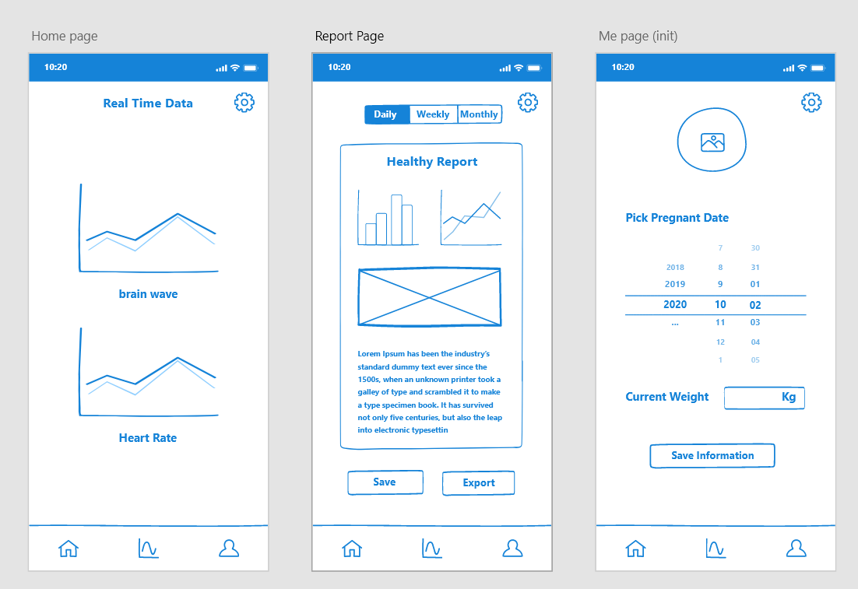

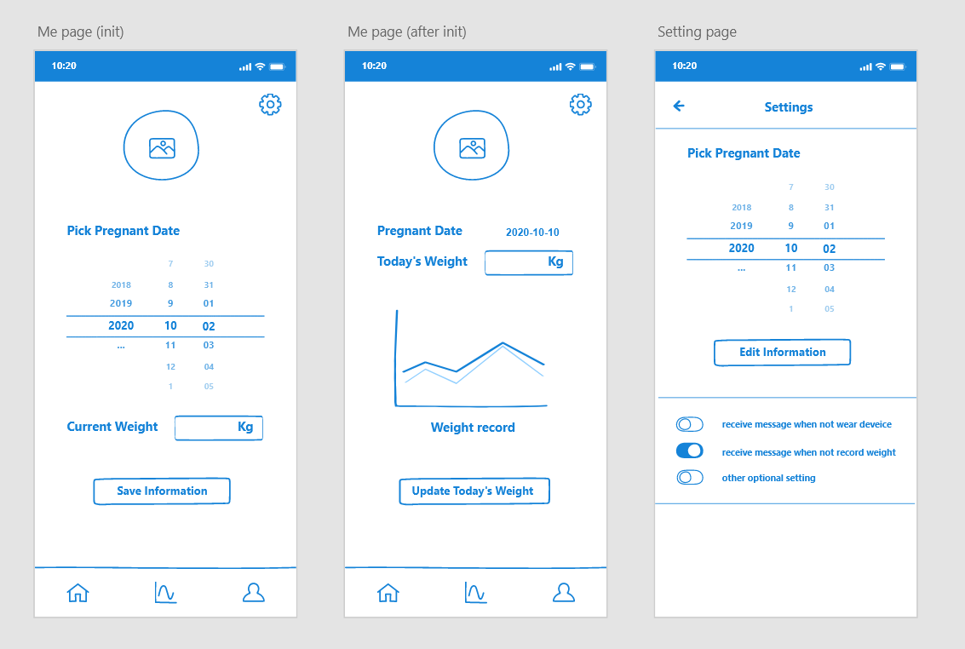

* 1. **Final System Implementation**

1. **Schedule**

The Gantt graph of the whole project is shown below:

|  |  |  |  |
| --- | --- | --- | --- |
| **列1** | **start** | **spend** | **finish** |
| **Bid submission** | **2020/9/25** | **11** | **2020/10/6** |
| **equipment requests** | **2020/10/6** | **205** | **2021/4/18** |
| **1 Define specification** | **2020/10/6** | **30** | **2020/11/5** |
| **Finish group project site up** | **2020/10/6** | **22** | **2020/10/28** |
| 1.1 Interview users(supervisor) | 2020/10/6 | 6 | 2020/10/12 |
| 1.2 Define user requirements | 2020/10/12 | 6 | 2020/10/18 |
| **Project Plan** | **2020/11/5** | **38** | **2020/12/13** |
| 1.3 Define system requirements | 2020/10/18 | 6 | 2020/10/24 |
| 1.4 Interpret equipment requests | 2020/10/24 | 6 | 2020/10/30 |
| 1.5 Identify data requirements | 2020/10/30 | 6 | 2020/11/5 |
| **2 System & Software design** | **2020/11/5** | **30** | **2020/12/5** |
| 2.1 General design | 2020/11/5 | 4 | 2020/11/9 |
| 2.2 UI design | 2020/11/9 | 3 | 2020/11/12 |
| 2.3 Modeling design | 2020/11/12 | 5 | 2020/11/17 |
| 2.4 Algorithm implementation | 2020/11/17 | 3 | 2020/11/20 |
| 2.5 Comprehensive evaluation | 2020/11/20 | 5 | 2020/11/25 |
| **Interim report** | **2020/11/25** | **19** | **2020/12/14** |
| **3 Implementation & coding** | **2020/12/14** | **52** | **2021/2/4** |
| 3.1 Realize UI | 2020/12/14 | 10 | 2020/12/24 |
| 3.2 Build & implement mathematical model | 2020/12/24 | 18 | 2021/1/11 |
| 3.3 Establish database | 2021/1/11 | 15 | 2021/1/26 |
| 3.4 Implementation of EA version | 2021/1/26 | 9 | 2021/2/4 |
| **4 Testing & refactoring** | **2021/2/4** | **35** | **2021/3/11** |
| 4.1 Test plan | 2021/2/4 | 8 | 2021/2/12 |
| 4.2 Unit test | 2021/2/12 | 9 | 2021/2/21 |
| 4.3 Integration testing | 2021/2/21 | 9 | 2021/3/2 |
| 4.4 Debugging & Refactoring | 2021/3/2 | 9 | 2021/3/11 |
| **5 Updating & Maintenance** | **2021/3/2** | **38** | **2021/4/9** |
| 5.1 Functions updating | 2021/3/2 | 15 | 2021/3/17 |
| 5.2 System maintenance | 2021/3/17 | 23 | 2021/4/9 |
| **Team final reports & software** | **2021/2/4** | **55** | **2021/3/31** |
| **Software Demonstration & Team presentation** | **2021/3/2** | **45** | **2021/4/16** |
| **Preparation for Open day & Presentation & Team live Q&A** | **2021/3/2** | **45** | **2021/4/16** |
| **Individual final reports due** | **2020/12/14** | **126** | **2021/4/19** |

1. **Groups (Member Assignment)**

**Software UI: Rongjiang Yang**

**Connection: ---**

**Algorithm transplantation: Hudie Liu, Xiaotian Xia**

**Function menu: Yiyang Li, Haonan Chen**

1. **System design**

**Data Capture module**

1. The mobile system (Android Application) can connect with the wearable devices which include heart rate belts, brain ware, smart scale, temperature sensor, breathing rate sensor, blood pressure sensor.

2. The vital signs will be measuring every minute. The vital data will be sent from wearable device to mobile application every 30 minutes.

3. The bodyweight data is captured by manual record.

4. The year and height are recorded from users.

5. The data will be sent to the integration module for the next step.

6. The connection between device and system is blue tooth.

**Data integration module**

1. The data will be updated every 30 minutes when the system collects data from wearable device.

2. The data will be processed and temporarily store in the application's memory.

3. Multiply types of data can be integration in the mobile system.

4. The received data will be stored for a month in the application memory for users' views.

5. The data will be split into different categories and shown to the users.

6. The data will be sent to the analysis module for the next step.

**Data report and analysis module**

1. Application could send a piece of message (every-day report) about the vital status analysis and advices at 8 a.m.

2. The report is about his/her body vital data. The report will include ever-day vital signs data after processing and will give some advices according to the analysis algorithm such as having more sleep or having abnormal status and need to see doctor.

3. The system could generate the report by the suggestion data and analysis algorithm daily and monthly (weekly)

4. The report could be persevered by users and exported.

**Data report and analysis module**

1. The data from users should be stored both in PC and mobile system.

2. Considering the limited memory, the details of past data will be cleaned up and the daily report will be stored in the mobile system.

3. The user could connect With the PC monthly and send the data for the long-term storage.

**Task management module (interface)**

1. The system will push the every-day reports, suggestions, and analysis at 8 a.m.

2. The system will send a message to user if user does not wear the devices.

3. The data capture function can be switch on/off.

4. The system will send a message if the user does not record the body weight until 8 p.m. every day.

5. The user can view three mode of application:

Current / last measured data

Today’s report

Long term report

settings

1. **Involving Device/Technique**

**Heart rate device**: Polar H10

**Brain ware device**: NeuroSky TGAM

**Smart scale device**: Yunmai

**Developing tools**: Genymotion simulator, Adobe XD, Android Studio.

1. **Reference**

1. 17 May 2017, Cardiovascular diseases (CVDs), http://www.who.int/news-room/fact-sheets/detail/cardiovascular-diseases-(cvds)

2**.** Anselmo J, Ryan A, Enrique A, Ycly J, Alberto C, Enrique J, 2015, Diabetes in Panama: Epidemiology, Risk Factors and Clinical Management

# 3.Bharah A, Xiaoying Y, Colin Wu, Kiang Liu, Gregory H, Royhn Mc, Antoinette S, Aaron R, Steven S, Eliseo G, David B, [João](https://www.ncbi.nlm.nih.gov/pubmed/?term=Lima%20JA%5BAuthor%5D&cauthor=true&cauthor_uid=28794054) A. 2017. Cardiovascular Event Prediction by Machine Learning: The Multi-Ethnic Study of Atherosclerosis

4**.** Marcus, S.M., 2009. Depression during pregnancy: rates, risks and consequences. Journal of Population Therapeutics and Clinical Pharmacology, 16(1).

5. Ye, C., Ruan, Y., Zou, L., Li, G., Li, C., Chen, Y., Jia, C., Megson, I.L., Wei, J. and Zhang, W., 2014. The 2011 survey on hypertensive disorders of pregnancy (HDP) in China: prevalence, risk factors, complications, pregnancy and perinatal outcomes. PloS one, 9(6), p.e100180.

6.Leng, J., Shao, P., Zhang, C., Tian, H., Zhang, F., Zhang, S., Dong, L., Li, L., Yu, Z., Chan, J.C. and Hu, G., 2015. Prevalence of gestational diabetes mellitus and its risk factors in Chinese pregnant women: a prospective